District 11 Treasurer’s Report April 2025

Delivery date 5/1/25

Over the past month we have had Income of $1,484.00 and Expenses of $644.68. This puts our available funds at $5,203.60 based on our prudent reserves.

I have updated the contribution receipt letter to include the following:
In an effort to streamline our process and be fiscally responsible we will be phasing out our contribution envelopes that get mailed with your receipt. In the future we will be sending your receipts via email.

I will now read the contribution letter for you.

At the end of the year, we will be utilizing a new PO Box half the size of our current one to save $58 annually. The cost went up for our next renewal and we don’t need one this big.

Any questions?

Motion to accept April report?
All those in favor?
Any opposed?

In keeping with our 7th Tradition, we are self-supporting through our own contributions. The suggested donation is $2 for this meeting.

Thank you!

Yours in service
Angelo Gallegos
Treasurer@aa-nia-dist11.org
Lomaster1313@aol.com
815-678-4034
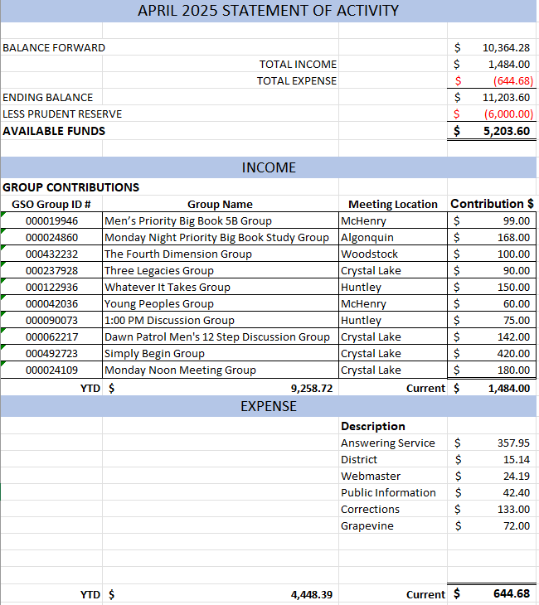
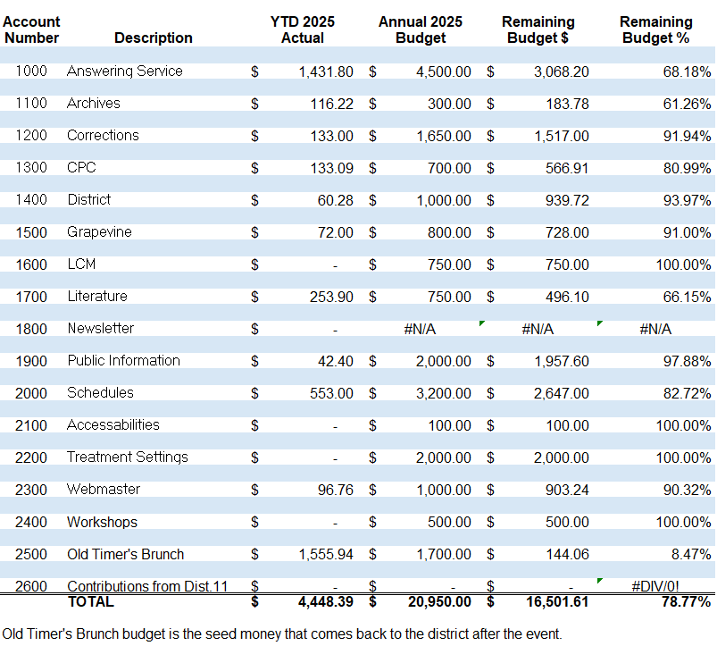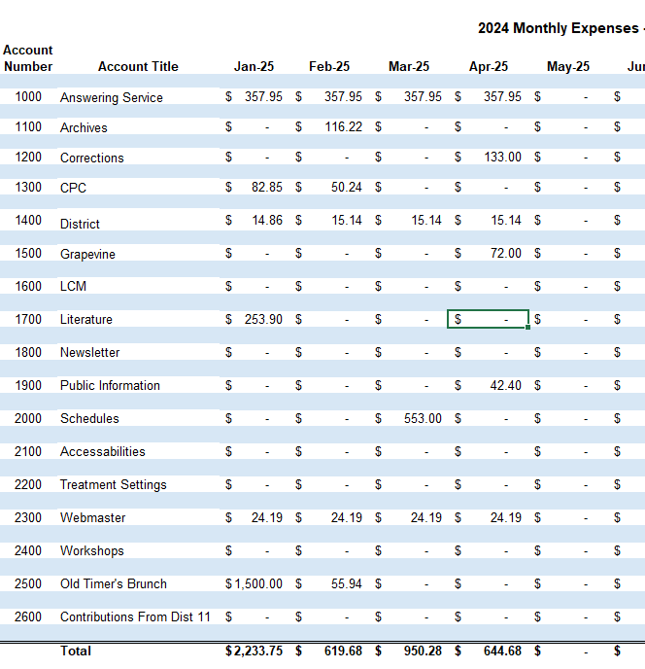

April 7, 2025

Dear AA Group Members,

Tracy Higgins
849 Barlina Rd.
Crystal Lake, IL 60014

On behalf of Northern Illinois Area District 11 we thank you!

This is your receipt for your group’s generous contribution:

Group: Monday Noon Meeting Group
Group ID # 000024109
Location: Crystal Lake
Contribution Amount: $180.00

Your contribution to District 11 helps to carry the message to recovering alcoholics and still suffering alcoholics in McHenry County and beyond. Some of the services your group helps us provide are:

- Maintaining the answering service which is how many alcoholics make their first contact with members of Alcoholics Anonymous
- Maintain our website http://aa-nia-dist11.org so it can be available for meeting information, to learn about Alcoholics Anonymous and recovery events and activities
- Provide Big Books to McHenry County Jail and local treatment centers

Our district meeting is held the first Thursday of each month at First Church, 236 W. Crystal Lake Ave., Crystal Lake, IL and via Zoom at 7pm. (Login number: 959 6776 4900 Password: District11) This is the time for the General Service Representative (GSR) to represent your group in District 11 decisions, obtain information about what is happening in Northern IL Area 20, AA World Services, and share your group conscience. As always, all AA members are welcome to attend to learn more about what District 11 is all about.

We ask that when making a group contribution that you specify your group’s name and GSO Group ID# in the "memo" portion of your check. Please see our website to obtain our new contribution form. You can also find your group’s number on our district’s website under the Meeting Schedules drop down select PDF Meeting Schedule or seek assistance by contacting our DCM at DCM@aa-nia-dist11.org.

In an effort to streamline our process and be fiscally responsible we will be phasing out our contribution envelopes that get mailed with your receipt. In the future we will be sending your receipts via email.

Yours in Service,
Angelo G., Treasurer
TBD, Alternate Treasurer
Northern Illinois Area District 11
PO Box 846
McHenry, IL 60051
Treasurer@aa-nia-dist11.org

